If you were to walk into a Geography lesson at East Preston Infant School, you would see:
- Children showing a curiosity about geography by asking questions to find out more
- Children using key vocabulary in whole class/group/paired discussions
- Children using a variety of resources to find out about the world around them, e.g., globes, atlases, aerial views, Google Earth
- Opportunities such as Forest School and Beach School and visiting places in the local area, e.g. the church/library
- Cross curricular links with other subjects such as science (weather and seasons)
- In EYFS – children begin to explore their own surroundings and compare these to other areas around the world, use stories/experiences to understand that there are different countries around the world and begin to draw simple maps (e.g., pirate treasure map)
- In Year 1 – children develop their geographical vocabulary and understanding of seasons and weather. They find out about the countries and cities of the UK and begin to look at human and physical features within these and read and draw simple maps
- In Year 2 – continue to build upon this and begin to look further afield, e.g. finding out about the 7 continents and 5 oceans, looking at hot and cold areas of the world as well as using compass points and simple maps with keys
What happens if my child struggles and finds it hard?:

- Pre – teaching (sneaky peeks)
- Adult support during lessons to develop vocabulary and understanding
- Adapted activities
What if my child is showing secure understanding, how are they challenged?:
- Targeted questions to deepen the understanding of a geographical theme
- Broadening and extending geographical vocabulary
What learners at East Preston Infants say about Geography:
Reception – “I liked making pirate treasure maps.”
Year 1 – “I like watching the trees change at Forest School. There is lots of trees there.”
Year 2 – “At beach school we play the North, South, East West game. It is so fun!”
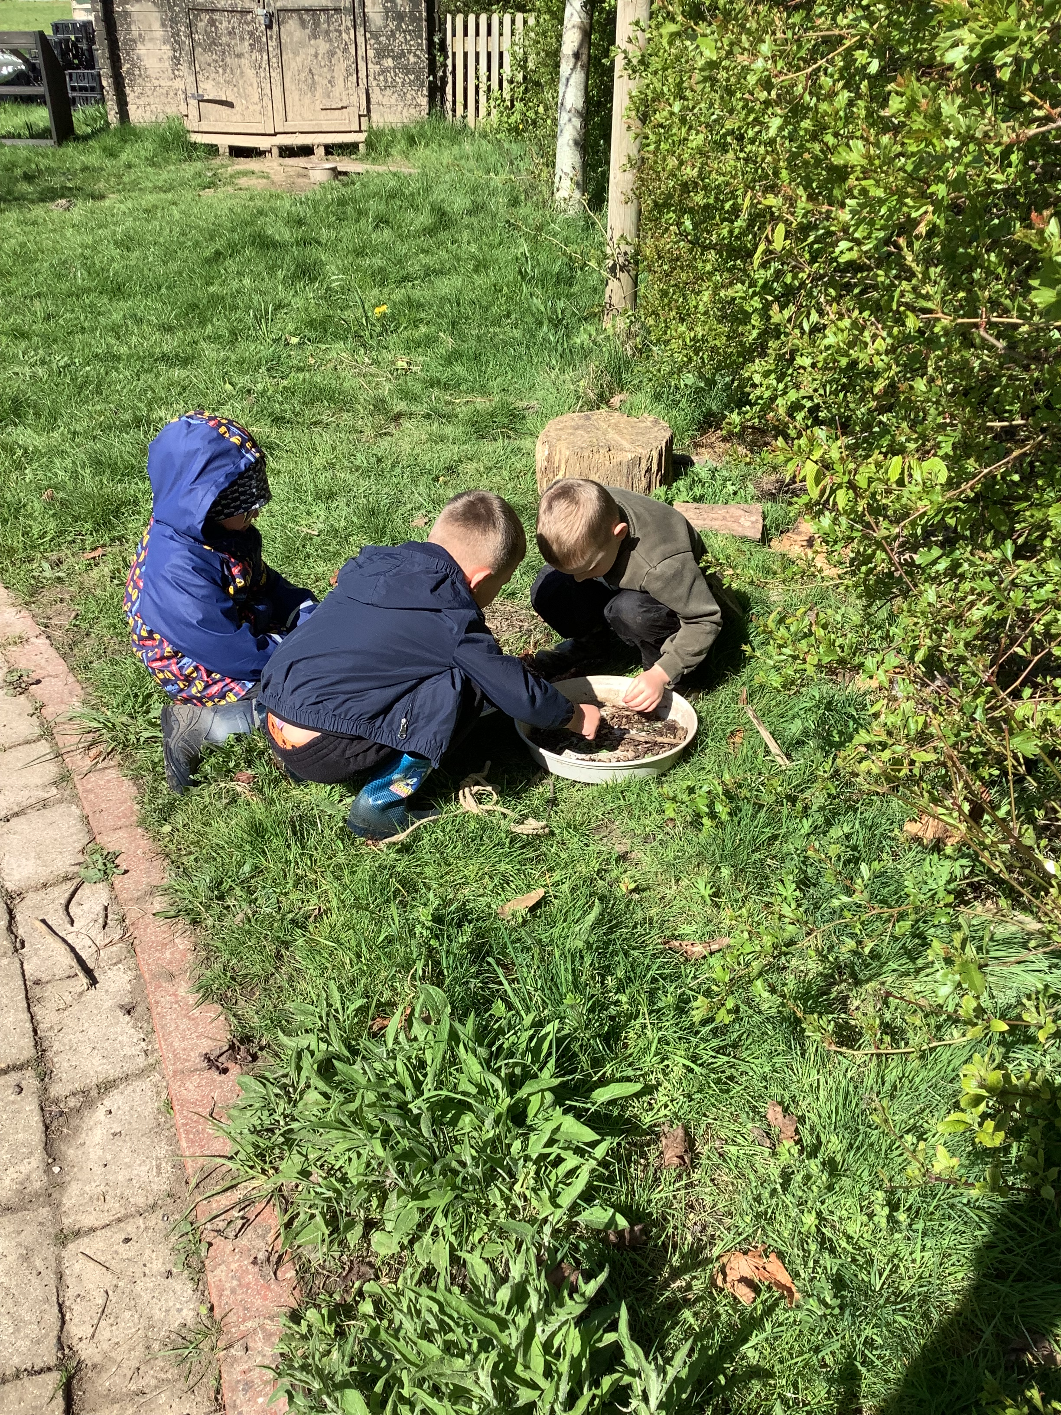
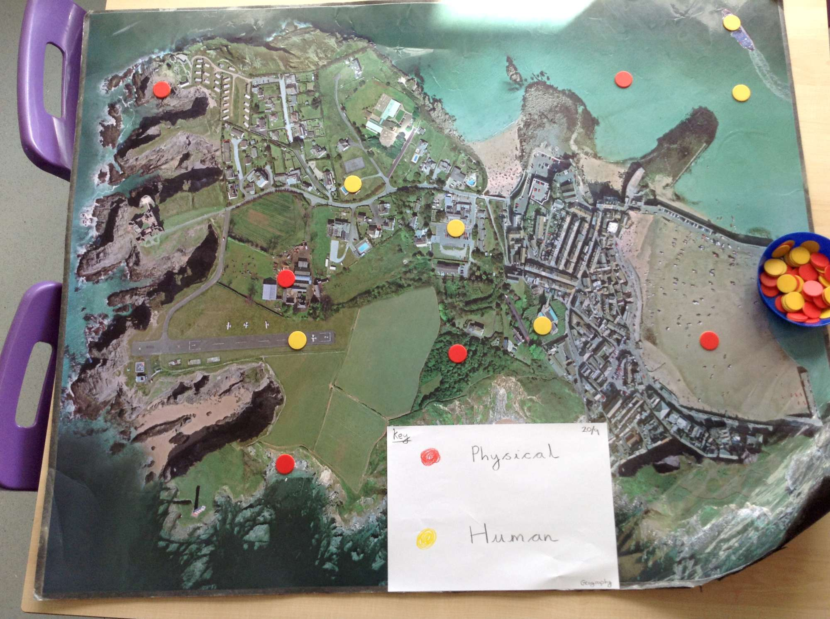
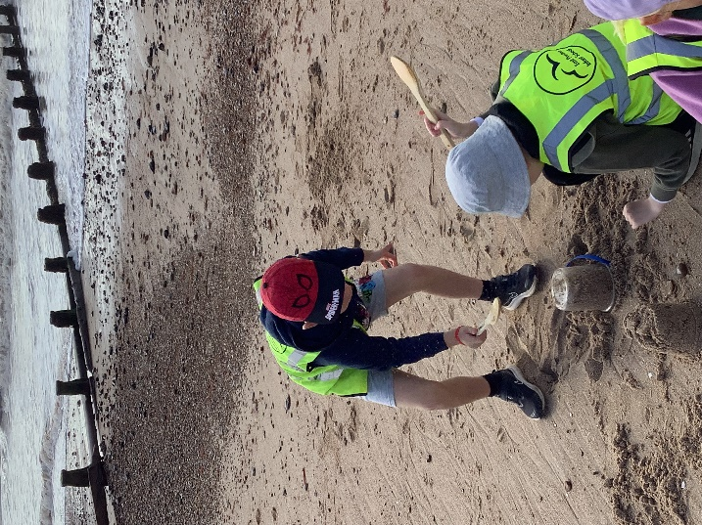

Successes in 2023-2024:
- Enrichment through Beach and Forest School sessions.
- Local walks to the church, library and beach helped to support the children with their understanding of the features of our local area as well as human and physical features.
- Provocation (‘bumping into’) Geography around the school in corridors / Outdoor Classrooms.

Focus for 2024-2025:
- New curriculum to be embedded following on from previous year.
- Collecting pupil voice to ensure Geography is understood and remains a high profile subject.

